Services we are going to build:  
1. Product Service

2. Order Service

3. Inventory Service

4. Notification Service

Note: Order service, inventory service, and notification service are going to interact with

Each other.

Solution architecture diagram  
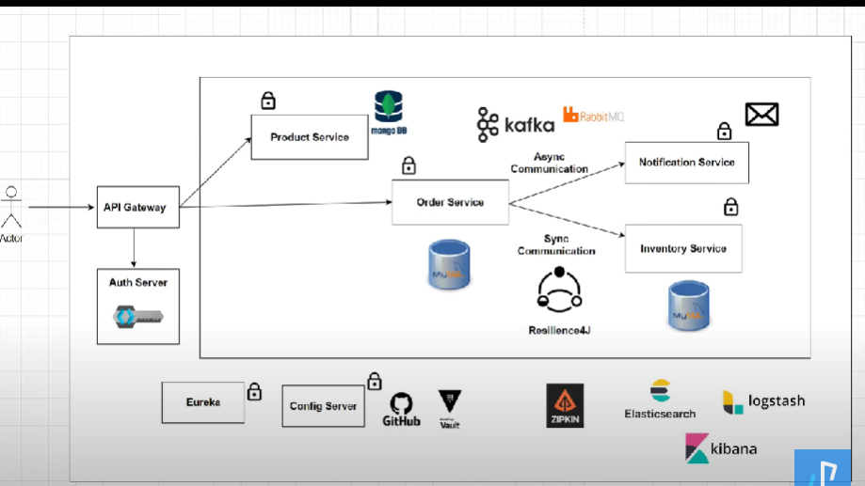

Logical architecture of services:  
